

**Pregnant?**

**You can now self-refer for maternity care at Aneurin Bevan Hospitals; using a quick online form.**

**There is no need to visit your GP first.**

**Use this QR code to inform us of your pregnancy. It's quick and easy and takes just a couple of minutes.**

**Alternatively, please use this link to visit the website and select Aneurin Bevan SPA:**

<http://www.badgernotes.net/selfreferral/AneurinBevan>

**We will triage your referral based on the information you provide and our midwives will contact you to start your antenatal care.**

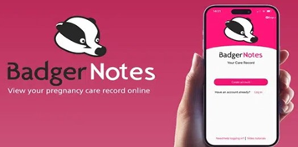

. **In the meantime, if you are worried about**

**your pregnancy, please contact your GP**

 **straight away**